EXPERIMENT NO. 18
IMAGE CROPPING, COPYING AND PASTING TO SELECT A REGION OF INTEREST USING OPENCV
PROGRAM:
import cv2

# Read the input image
img = cv2.imread("roi_input.png")

if img is None:
print("Image not found! Check the filename.")
else:
# Define the region of interest (ROI)
x, y, w, h = 100, 80, 250, 200

# Crop the selected region
roi = img[y:y+h, x:x+w]

# Copy the cropped region
roi_copy = roi.copy()

# Paste the copied region at a new location
paste_x, paste_y = 400, 250
img[paste_y:paste_y+h, paste_x:paste_x+w] = roi_copy

# Draw a rectangle around the original ROI
cv2.rectangle(img, (x, y), (x+w, y+h), (0, 0, 255), 2)

# Display the images
cv2.imshow("Original Image with ROI", img)
cv2.imshow("Cropped ROI", roi)
cv2.imshow("Image with Pasted ROI", img)

# Save the final image
cv2.imwrite("roi_result.png", img)

print("ROI cropped, copied and pasted successfully!")

cv2.waitKey(0)
cv2.destroyAllWindows()
COMMANDS USED:
cd Desktop
cd opencv
python experiment18_roi.py

OUTPUT:
The selected region of the input image was cropped and displayed separately. The copied region was pasted at a new location in the image. The final output was saved as roi_result.png.
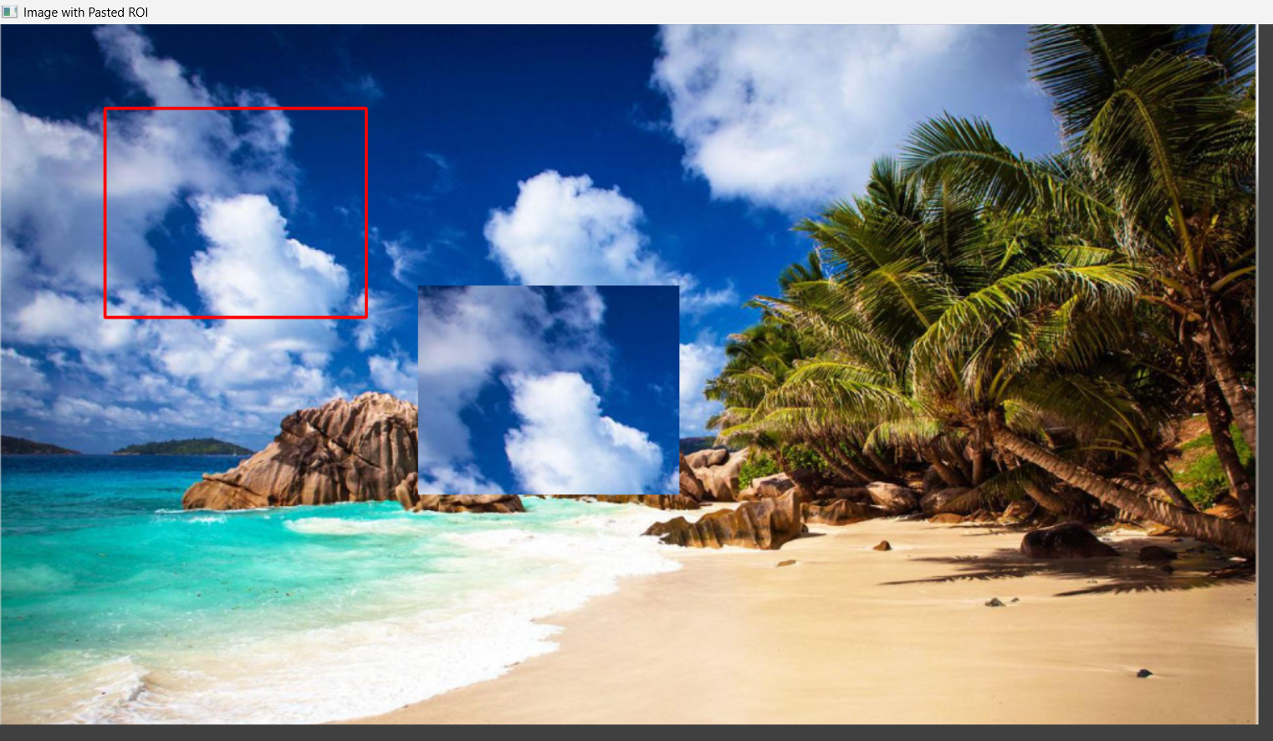
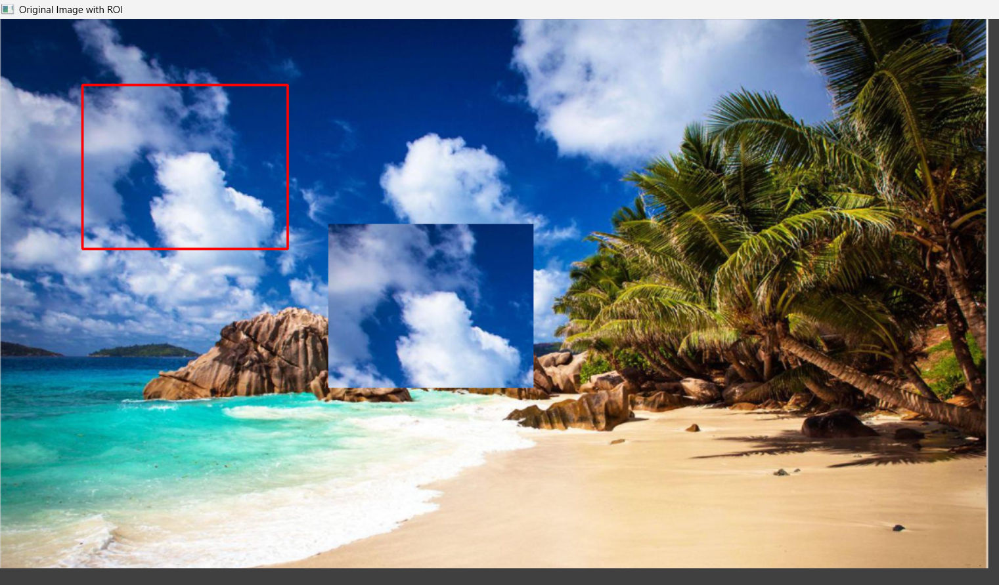
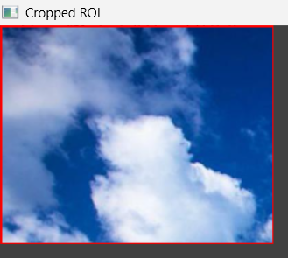

RESULT:
The program was successfully executed using OpenCV to crop, copy, and paste a selected Region of Interest (ROI) from the source image.

